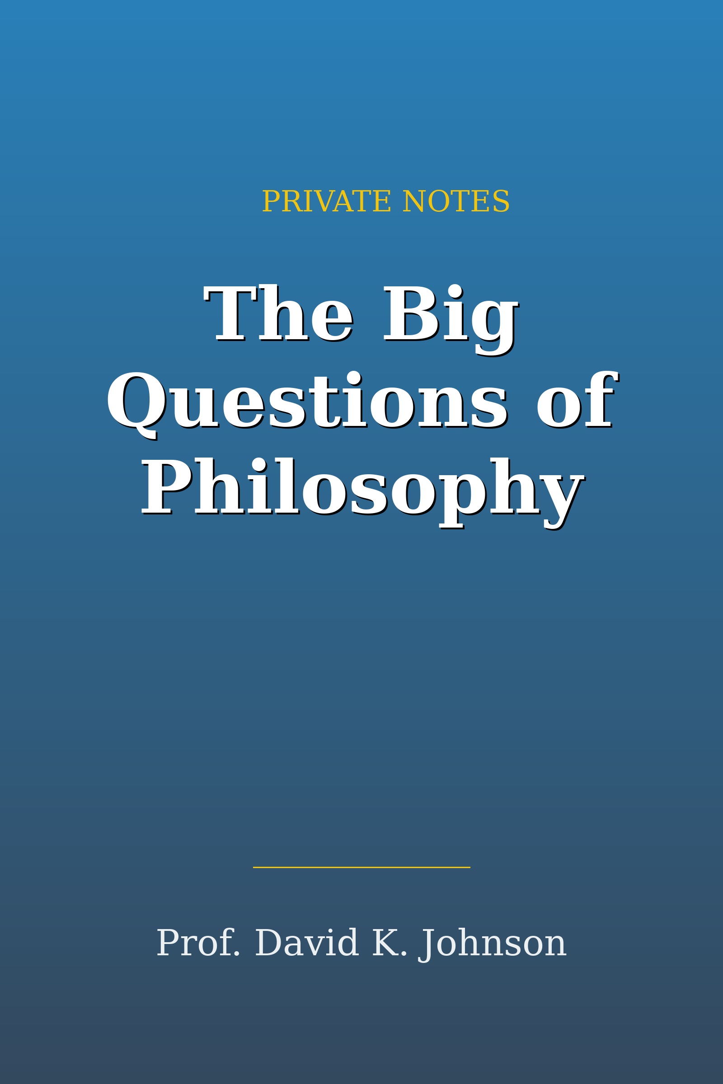

Table of Contents
──────────────────────────────

Lecture 1: Lect34 What Are the Limits of Liberty
Lecture 2: Lect35 What Makes a Society Fair or Just
Lecture 3: Lect36 What Is The Meaning of Life

──────────────────────────────

Lecture 1

Lect34 What Are the Limits of Liberty

──────────────────────────────

"Liberty should be protected, he argued, because that is the most effective way to ensure the most happiness for the most people."

Key Takeaways
- - Liberty and Government: The government should only restrict actions that risk harm to others, allowing individuals the freedom to pursue their happiness without legal interference.
- Example: Legalizing marijuana, as its use primarily affects the individual user.
- - Tyranny of the Majority: Protecting minority rights from majority oppression is essential in a democracy, highlighting the need for laws that safeguard individual freedoms.
- Example: Legal recognition of same-sex marriage to protect the rights of LGBTQ+ individuals.
- - Freedom of Speech: Mill contends that all speech, even offensive or unpopular, should be protected to ensure a vibrant discourse and the pursuit of truth.
- Example: Allowing hate speech to be expressed so that it can be challenged and debunked.
- - Restrictions on Liberty: Actions that cause definite harm to others can justifiably be restricted, but personal choices that only affect oneself should remain free.
- Example: Legally prohibiting speeding to prevent potential accidents.
- - The Role of Morality in Law: Mill posits that morality should not dictate legal standards unless an action causes harm to others, emphasizing the distinction between legal and moral behavior.
- Example: Adultery may be immoral but should not be illegal.

──────────────────────────────

Lecture 2

Lect35 What Makes a Society Fair or Just

──────────────────────────────

"A just society is a fair society, and we should aim to make society as fair as possible."

Key Takeaways
- - A just society is defined by fairness and equality.
- Example: Rawls' original position allows for the creation of equitable societal rules.
- - Individual liberties must be preserved while ensuring they do not infringe upon others.
- Example: Rawls' first principle emphasizes equal rights to basic liberties.
- - Economic inequalities are acceptable only when they benefit the least advantaged.
- Example: Rawls' second principle supports social mobility and welfare programs.
- - Wealth redistribution raises moral questions about individual rights.
- Example: Nozick argues that taking from the wealthy to give to the poor is unjust.
- - The search for a just society involves reconciling individual rights with the need for social equity.
- Example: The discourse between Rawls and Nozick highlights the complexity of achieving societal justice.

──────────────────────────────

Lecture 3

Lect36 What Is The Meaning of Life

──────────────────────────────

Key Takeaways

